APPLICATION BUILD SPECIFICATION
Psychometrics Data Science Application
Reference Architecture, Functional Design, Workflow, and Development Standard

Field | Specification
Document type | Software Design / Technical Specification
Status | Draft baseline for implementation
Primary environment | Microsoft 365 / SharePoint + local or hosted analytical compute
Implementation languages | Python, R, SAS, SQL; JavaScript/TypeScript only where required for UI integration
Primary users | Psychometricians, data scientists, analysts, reviewers
Version | 1.0

Purpose This document defines the intended application architecture and behavior before implementation. It is designed to serve as the authoritative build reference for developers, AI coding agents, reviewers, and QA staff.

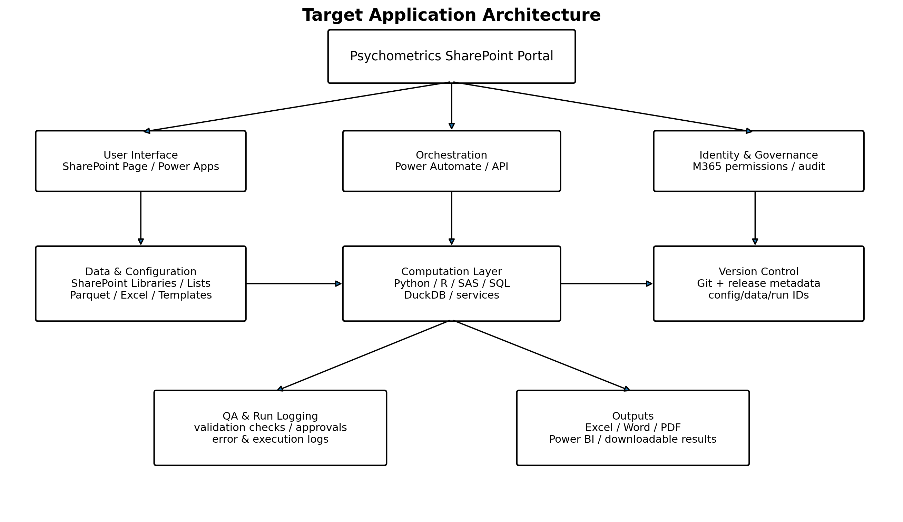

1. Executive Summary
The application is an internal psychometrics data-science platform for controlled ingestion, transformation, analysis, quality assurance, reporting, and distribution of analytical outputs. The design intentionally separates the user-facing workspace from the computational engine so that SharePoint can provide governed collaboration, identity, documentation, templates, run history, and report distribution while Python, R, SAS, SQL, or approved cloud compute perform analytical processing.
Design principle SharePoint is the governed workspace and application front door; it is not the analytical compute engine. Computation must execute in an approved local, server, container, Fabric, Databricks, or other hosted environment.

2. Goals and Non-Goals
Category | Definition
Primary goals | Standardize analytical workflows; reduce manual file handling; preserve reproducibility; centralize templates and documentation; support repeatable QA; provide governed sharing and approvals; export familiar deliverables.
Secondary goals | Enable incremental automation; support modular replacement of local compute with hosted services; permit multiple analysis engines; create consistent run metadata and release records.
Non-goals | Replace enterprise data warehouses; store very large analytical datasets directly in SharePoint Lists; execute long-running Python/R/SAS jobs inside SharePoint itself; remove required human review for high-stakes psychometric decisions.

3. Users and Roles
Role | Primary responsibilities | Typical access
Analyst / Psychometrician | Configure runs, execute analyses, review diagnostics, generate reports. | Create/edit project inputs and runs.
Reviewer / Approver | Review QA, methods, output, and release status. | Read inputs; update approval status.
Application Owner | Maintain templates, configuration, permissions, release baseline, and app settings. | Owner/admin within approved scope.
Developer | Maintain code, tests, APIs, and deployment packages. | Git/code access; controlled deployment rights.
Consumer / Stakeholder | View approved reports and dashboards. | Read-only published content.

4. Functional Modules and Parts
ID | Module | Core function | Primary implementation
M01 | Portal / Home | Provide navigation, project status, documentation, tool entry points, approved reports, and announcements. | SharePoint page
M02 | Project & Run Setup | Create/select project, dataset, analysis type, template/configuration, and output destination. | Power Apps / form / app UI
M03 | Data Intake | Select files from controlled libraries or upload approved input formats. | SharePoint library + intake component
M04 | Validation Engine | Validate file type, required columns, data types, allowable values, IDs, missingness, and duplicate rules. | Python/R/SAS/SQL service
M05 | Transformation Layer | Clean, join, reshape, derive variables, standardize coding, and create analysis-ready datasets. | Python/R/SAS/SQL
M06 | Analysis Engine | Execute psychometric/statistical analyses and reusable analytical pipelines. | Python/R/SAS
M07 | QA Engine | Run prespecified assertions, threshold checks, reconciliation, reasonableness checks, and result validation. | Automated tests + analyst review
M08 | Reporting Engine | Generate standardized Excel, Word, PDF, HTML, and optional dashboard outputs. | Quarto / Office libraries / Power BI
M09 | Run Log & Audit | Capture run ID, user, timestamps, code/config/data versions, parameters, warnings, errors, outputs, and status. | SharePoint List / database
M10 | Approval & Release | Route outputs for review; record reviewer, status, notes, and approval timestamp; expose only approved releases where appropriate. | Power Automate + SharePoint List
M11 | Template Library | Maintain controlled Excel/Word/report/config templates and reference files. | SharePoint document library
M12 | Code & Release Management | Version code, tests, schemas, and configuration; identify release used for each run. | Git / GitHub or approved enterprise Git
M13 | Notifications & Automation | Trigger notifications, scheduled jobs, approval requests, and status updates. | Power Automate / scheduler
M14 | Administration | Manage permissions, defaults, allowed analyses, template versions, retention, and operational settings. | Owner-only controls

5. Functional Requirements
ID | Requirement
FR-01 | The system shall allow an authorized user to create or select a project and analytical run.
FR-02 | The system shall associate every run with an immutable run identifier.
FR-03 | The system shall capture the source dataset identifier/version before execution.
FR-04 | The system shall validate required schemas and halt or warn according to configured rule severity.
FR-05 | The system shall allow analysis parameters to be saved as a versioned configuration.
FR-06 | The system shall execute approved Python, R, SAS, or SQL workflows through a defined compute interface.
FR-07 | The system shall store execution status, warnings, errors, timing, and output locations.
FR-08 | The system shall run automated QA checks before a run can be marked Ready for Review.
FR-09 | The system shall generate standard output artifacts including Excel and at least one narrative report format.
FR-10 | The system shall preserve a traceable relationship among data version, code version, configuration version, and output version.
FR-11 | The system shall distinguish Draft, Review, Approved, Superseded, and Failed run states.
FR-12 | The system shall restrict administrative functions to authorized owners.
FR-13 | The system shall support a reusable template library without requiring duplicate template copies embedded across documentation pages.
FR-14 | The system shall expose user-friendly error messages while retaining detailed technical logs for diagnosis.
FR-15 | The system shall permit future migration from local compute to an approved hosted API/service without redesigning the front-end workflow.

6. User Interface and Layout
The default layout follows a dashboard-and-workspace pattern. Navigation remains stable across pages; operational controls are separated from documentation and published outputs.
Area | Contents | Design intent
Global header | Application name, environment, user identity, help, version. | Immediate orientation and release awareness.
Left navigation | Home; Projects; New Run; Run History; Templates; Reports; Documentation; Administration. | Stable information architecture.
Home dashboard | Recent runs, items needing review, failed runs, shortcuts, notices. | Action-oriented landing page.
Run workspace | Step indicator; dataset selector; validation status; parameters; Run button; live/refreshable status; QA summary; outputs. | One primary task per page.
Run details | Run metadata, source/version identifiers, execution log, QA results, output links, approval history. | Single audit record.
Templates | Controlled template catalog with owner, version, status, purpose, and download/open links. | One authoritative template source.
Reports | Approved reports and dashboards filtered by project/status/date. | Separate released content from working files.

6.1 Suggested Run Workspace Wireframe
┌─────────────────────────────────────────────────────────────────────┐
│ Psychometrics App Environment: PROD | v1.0 │
├───────────────┬─────────────────────────────────────────────────────┤
│ Home │ NEW ANALYTICAL RUN │
│ Projects │ │
│ New Run │ 1 Dataset → 2 Validate → 3 Configure → Run │
│ Run History │ │
│ Templates │ Project [ Select project ▼ ] │
│ Reports │ Dataset [ Select controlled file ▼ ] │
│ Documentation │ Analysis [ Select analysis ▼ ] │
│ Admin │ │
│ │ Validation ✓ Schema ✓ IDs ! Missingness │
│ │ │
│ │ Parameters [ configuration controls ] │
│ │ │
│ │ [ SAVE CONFIG ] [ RUN ANALYSIS ] │
│ │ │
│ │ Status: Ready │
└───────────────┴─────────────────────────────────────────────────────┘

7. Application Workflow
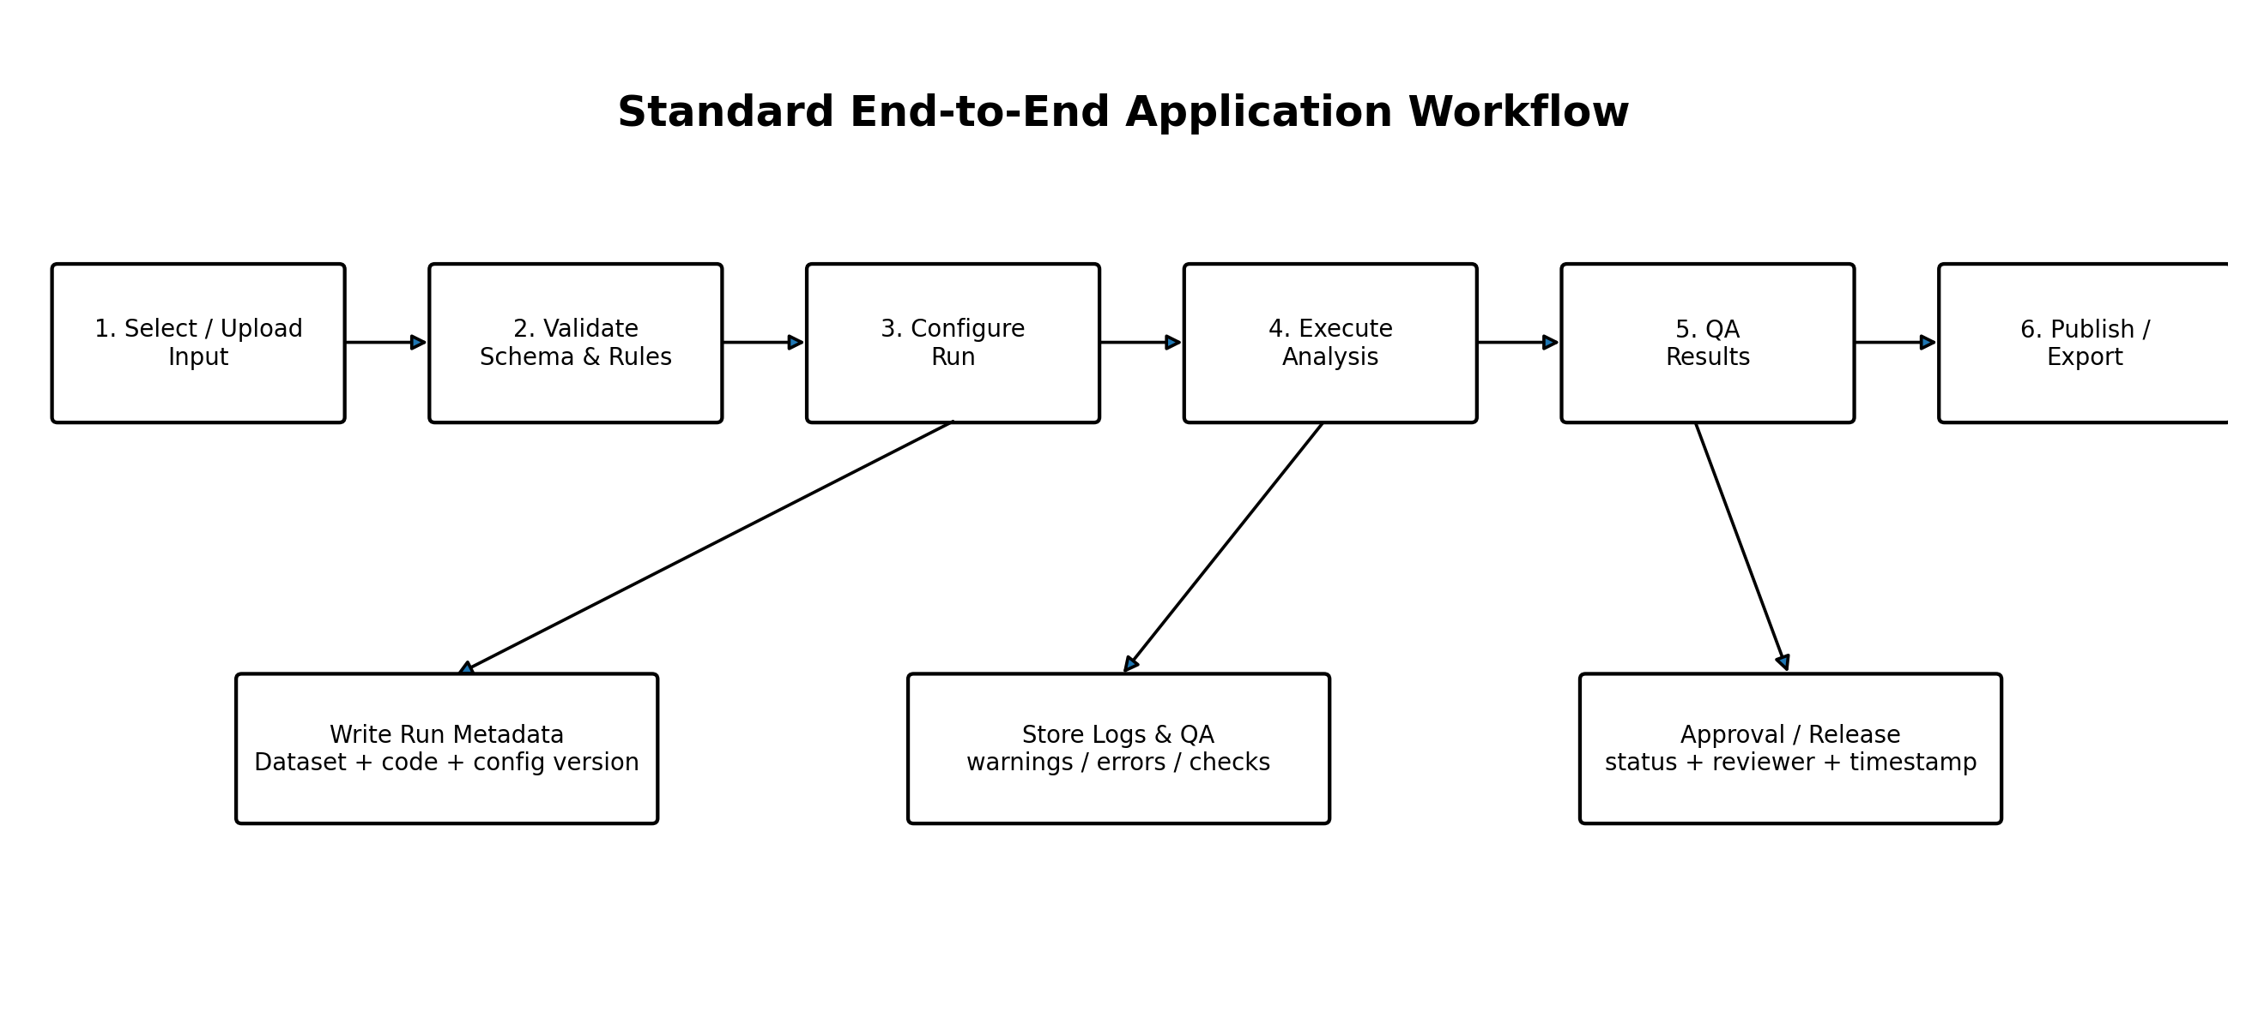
Stage | System behavior | Control / evidence
1. Intake | User selects project, source dataset, and analysis workflow. | Source location and dataset identifier captured.
2. Validation | Input is checked against schema and rule library. | Validation result stored; blocking errors prevent execution.
3. Configuration | User selects parameters and saves the run configuration. | Configuration is serialized/versioned.
4. Execution | Compute layer transforms data and runs the selected analysis. | Code release, runtime, status, warnings, and errors logged.
5. Automated QA | Assertions and threshold checks evaluate outputs. | QA summary stored with pass/warn/fail states.
6. Analyst Review | Analyst inspects diagnostics and outputs. | Ready for Review state requires defined minimum QA criteria.
7. Approval | Reviewer approves, rejects, or requests revision. | Reviewer identity, date, and comments retained.
8. Publication | Approved artifacts are copied/linked to controlled report locations. | Released output is linked to originating run ID.
9. Supersession | Later approved runs may supersede earlier releases without destroying history. | Prior release retained with Superseded status.

8. Architecture and Component Design

Layer | Responsibilities | Technology candidates
Presentation | Navigation, forms, parameter entry, status, links, summaries. | SharePoint pages, Power Apps; optional SPFx/Streamlit.
Orchestration | Trigger compute, move status between states, schedule tasks, notify users. | Power Automate, REST API, scheduler.
Computation | Transformation, statistics, optimization, psychometric QA, report generation. | Python, R, SAS, SQL; local or hosted compute.
Data | Controlled source files, analysis-ready data, configurations, outputs. | SharePoint libraries; Parquet/Excel; DuckDB; future lakehouse/database.
Audit metadata | Run, approval, error, QA, and release records. | SharePoint Lists or relational database.
Version control | Code, schemas, tests, config definitions, releases. | Git.
Reporting | Tables, figures, narratives, dashboards, export packages. | Excel, Word, PDF, HTML, Power BI, Quarto.

9. Data and Metadata Design
Entity | Minimum fields
Project | project_id, name, owner, status, description, created_date
Dataset | dataset_id, project_id, filename/location, dataset_version, source_date, schema_version, checksum or equivalent fingerprint
Run | run_id, project_id, dataset_id, analysis_type, config_version, code_version, requested_by, start_time, end_time, status
Configuration | config_id/version, analysis_type, serialized parameters, created_by, created_date
QA Result | run_id, rule_id, severity, result, observed_value, expected/threshold, message
Output | run_id, output_type, location, file/version identifier, created_date
Approval | run_id, reviewer, decision, comments, decision_date
Error/Warning | run_id, stage, severity, technical_message, user_message, timestamp

10. Versioning and Traceability Standard
Every published result must be reproducible from the combination of four identifiers: data version, code version, configuration version, and run ID. Human-readable file names may change; these identifiers must remain stable.
Object | Version source | Example
Code | Git commit/tag | app-v1.4.2 / commit a1b2c3d
Data | Controlled file version + fingerprint | dataset_id DS-014 / SharePoint v7
Configuration | Serialized config version | CFG-AISI-003
Execution | Unique run ID | RUN-20260813-0017
Output | Run-linked artifact version | RUN-20260813-0017_report.docx

11. Logging, QA, and Approval States
State | Meaning | Allowed next states
Draft | Run defined but not executed or not ready. | Running, Cancelled
Running | Compute is executing. | QA Review, Failed
QA Review | Automated QA completed; analyst review required. | Ready for Review, Revision Required, Failed
Ready for Review | Analyst indicates results are reviewable. | Approved, Revision Required
Approved | Reviewer accepts release. | Published, Superseded
Published | Approved output is exposed to intended consumers. | Superseded
Revision Required | Changes are required; prior run remains immutable. | New run
Failed | Execution or blocking QA failed. | New run
Superseded | A later approved release replaces this one. | None; retained for audit

12. Error Handling
Error class | User behavior | System behavior
Input/schema error | Explain what is missing or invalid and how to correct it. | Do not execute; record validation failure.
Data quality warning | Allow continuation only when rule severity permits. | Record warning and acknowledgment if applicable.
Compute failure | Show concise failure state; do not expose raw stack trace to ordinary users. | Persist technical log and partial diagnostics.
Output generation failure | Mark run incomplete; do not label as Approved/Published. | Retain analysis results where safe and log report failure.
Permission error | Explain access requirement without revealing restricted content. | Record access failure where appropriate.
Integration/network error | Allow safe retry without duplicating immutable run records. | Use idempotent trigger pattern where feasible.

13. Nonfunctional Requirements
Area | Standard
Security | Use organizational identity and least-privilege permissions; no credentials stored in source code.
Privacy | Handle research/test data according to organizational classification and retention requirements.
Reproducibility | Published outputs must be traceable to data, code, configuration, and run identifiers.
Maintainability | Use modular components, documented interfaces, automated tests, and configuration rather than hard-coded project logic.
Usability | Primary workflows should be understandable without source-code knowledge; blocking errors should be actionable.
Performance | Long-running work must not depend on a browser session remaining open.
Reliability | Run records should be immutable after execution except for controlled status/approval metadata.
Accessibility | Use accessible headings, labels, contrast, keyboard navigation, and accessible report templates where platform support allows.
Portability | Compute interface should allow local development and future hosted execution without changing analysis definitions.
Observability | Capture stage, status, duration, warnings, failures, and output locations for each run.

14. Testing Strategy and Acceptance Criteria
Test level | Purpose | Examples
Unit | Verify individual functions. | Schema checks, scoring rules, transformations, calculations.
Integration | Verify components work together. | SharePoint intake → API → compute → result write-back.
Regression | Ensure new releases do not change validated behavior unexpectedly. | Known datasets with expected outputs.
Data validation | Verify incoming and derived data meet declared rules. | Ranges, uniqueness, required fields, cross-field logic.
User acceptance | Confirm workflow supports analyst/reviewer needs. | Complete representative run without developer intervention.
Security/permissions | Confirm roles can access only intended content/actions. | Consumer cannot edit templates; analyst cannot administer permissions.
Release smoke test | Verify core path after deployment. | Create run, validate, execute, open output, complete approval.

Minimum acceptance gate A release is not production-ready until critical functional requirements pass, representative analytical results match validated reference outputs, permissions are verified, error logging works, and at least one complete run can be traced from source dataset through approved output.

15. Development and Release Workflow
Phase | Deliverable / gate
1. Define | Approved problem statement, user roles, scope, acceptance criteria.
2. Design | Updated build spec, architecture, UI/workflow, data schema, interfaces.
3. Implement | Feature branch/code changes, unit tests, documentation.
4. Review | Code review plus psychometric/methodological review where applicable.
5. Validate | Regression dataset, QA results, UAT evidence.
6. Release | Version tag, release notes, deployment package, migration/config notes.
7. Operate | Run monitoring, issue tracking, template/config maintenance.
8. Change control | Material behavior changes require spec update and new validation evidence.

16. Recommended Repository / Project Structure
app/
├── src/
│ ├── intake/
│ ├── validation/
│ ├── transformation/
│ ├── analysis/
│ ├── qa/
│ ├── reporting/
│ └── integrations/
├── config/
├── schemas/
├── templates/
├── tests/
│ ├── unit/
│ ├── integration/
│ └── regression/
├── docs/
│ ├── build_spec/
│ ├── decisions/
│ └── user_guide/
├── scripts/
├── sample_data/ # synthetic/non-sensitive only
├── pyproject.toml / requirements files
├── README.md
├── CHANGELOG.md
└── .gitignore

17. Architecture Decision Records (ADR)
Material design decisions should be recorded separately rather than buried in code comments. Each ADR should identify the context, decision, alternatives considered, consequences, owner, and date. Examples include selection of SharePoint as the portal, DuckDB versus SQLite, report-generation framework, compute hosting model, and the boundary between Power Apps and custom code.

18. Implementation Phases
Phase | Scope | Exit criterion
Phase 1 - Local MVP | Local Python/R/SAS/SQL compute; SharePoint libraries/templates; manual run registration. | One complete controlled workflow works end-to-end.
Phase 2 - Governed Workflow | SharePoint Lists for run/approval logs; Power Automate notifications; standardized reports. | Run history and approvals no longer depend on email/manual notes.
Phase 3 - Shared Application | Power Apps or custom front end invokes approved compute service/API. | Coworkers can execute approved workflows without local developer setup.
Phase 4 - Scaled Platform | Hosted compute, centralized data layer, CI/CD, monitoring, expanded tool catalog. | Multiple production workflows share common platform services.

19. Definition of Done
- Functional requirements for the release are implemented and traceable to tests.
- Automated QA passes on reference data and discrepancies are documented.
- User-facing workflow and error messages are reviewed.
- Code, configuration, and schemas are version controlled.
- Run logging captures required traceability fields.
- Security and permission behavior is verified.
- User documentation and release notes are updated.
- Reports/exports open correctly in target Office/PDF environments.
- Known limitations and deferred items are documented.
- The build specification is updated to reflect implemented behavior.

20. Build Spec Change Log
Version | Date | Change | Owner
1.0 | 2026-08-13 | Initial reference architecture and professional software-development baseline. | Application Owner

